Accessible Powerpoint presentations
This tutorial is based on Microsoft powerpoint 2013.

Before we begin, an important aspect needs to be addressed:
Installed voices on your computer or portable device play a big part in how the accessible document is spoken. Synthetic, electronic voices are not created equal. Some are robotic and some are human-like. Most voices today, even the preinstalled ones on a computer are considered human-like. However, even if they are considered human-like, some have better quality than others. For example, some human-like voices are very clear, but they may not speak technical terms like Biology, Chemistry, etc. very well. In contrast, other human-like voices may not be as clear, but speak technical terms well. So, it truly depends on the manufacturer of the voice and how much effort the developers put into the programming of the voice. To really understand the innate differences of electronic, human-like voices, you have to listen to them as they speak various words and other document features.

STEPS:
1. Add content to all your slides.

2. Any pictures, charts, graphs, tables, etc. require a description to be added to them if they are an integral part in understanding the presentation. You can either add a caption below the item to describe what is represented or you can add alternate text to the item. Sometimes, both captions and alternate text are added to the item. When in doubt, always add alternate text to the item. To do this, you simply right click on the item and choose “Format Picture”.

3. The “Format Picture” Task Pane opens on the right.

4. Choose “Size and Properties” in the “Format Picture” Task Pane.

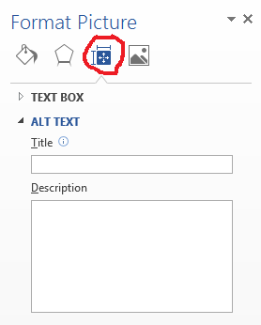
5. Under “Size and Properties” open “Alt Text”. You can add a Title if you like, but you should definitely add an alternate text Description.
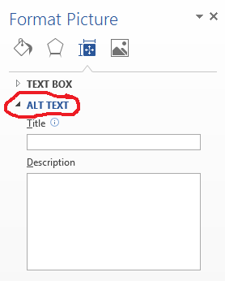
6. Perform steps 2 to 5 above for all items in the slideshow requiring a caption and/or alternate text description.
7. Click on the “Home” tab and choose “Arrange”.
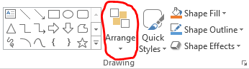
8. Choose “Selection Pane” under “Arrange” and items in this list can be moved up or down for the current slide. The reason for adjusting the items in the list on the current slide is to make sure a screen reader will read the items on the slide in a logical order, top-to-bottom, left-to-right. In the “Selection Pane”, items on the slide are read by a screen reader from the bottom most item in the list first to the top most item in the list last. When moving items up or down in the “Selection Pane” be careful because this list also arranges the items on the slide front-to-back in a layered fashion. In other words, the top most item on the slide will be the bottom most item in the list that is read first by a screen reader. When arranging items in this list, make sure no items in the list are hiding and preventing another item on the slide from being seen.
9. Perform step 8 above for every slide in the presentation.
10. Once all items per slide have been ordered properly in the “Selection Pane” and no items on the slides are hiding any other items from view, save the presentation.
11. The PowerPoint Presentation should now accessible to screen readers for blind access.

12. To make sure the PowerPoint Presentation is accessible, you can run the built-in Accessibility Checker by clicking on the File tab and choosing Check for Issues and then Check Accessibility. This will display a list of potential accessibility issues, if any, and will guide you in fixing these problems.
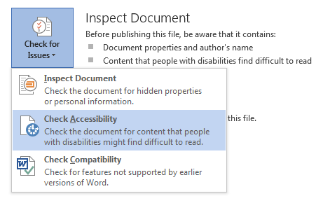

Revised: March 2016

