Accessible pdf documents, A Beginners Tutorial
This tutorial is based on adobe acrobat pro dc.

Before we begin, an important aspect needs to be addressed:
Installed voices on your computer or portable device play a big part in how the accessible document is spoken. Synthetic, electronic voices are not created equal. Some are robotic and some are human-like. Most voices today, even the preinstalled ones on a computer are considered human-like. However, even if they are considered human-like, some have better quality than others. For example, some human-like voices are very clear, but they may not speak technical terms like Biology, Chemistry, etc. very well. In contrast, other human-like voices may not be as clear, but speak technical terms well. So, it truly depends on the manufacturer of the voice and how much effort the developers put into the programming of the voice. To really understand the innate differences of electronic, human-like voices, you have to listen to them as they speak various words and other document features.

Before beginning this tutorial, some key points need to be covered:

1. For this tutorial, it is based on the latest version of Adobe Acrobat Pro called “Adobe Acrobat Pro DC”. Previous versions of Adobe Acrobat Pro will be similar.

2. When talking about “tags”, “tagging”, or “tagged”, those terms refer to special labels added to the content in a PDF that enable the PDF to be accessible. Hence, the term “Tagged PDF”.

3. When talking about an accessible PDF that is one in which the text in a PDF can be spoken by a screen reader for blind access.

4. Also, a lot of advanced accessible PDF remediation will not be covered because much of that is better understood when shown instead of being written. As a result, accessible PDF remediation is labor intensive. It takes work and time to create a properly accessible PDF document. Also, experience plays a large part in advanced accessible PDF remediation. Having said all that, this tutorial, like the title states, is for beginners and covers only the most basic PDF accessibility concepts and in no way implies that this tutorial is a remedy for every PDF issue you may encounter.

5. Lastly, there are three types of PDF’s: Image, Searchable and Tagged:

A. Image PDF: Not accessible to screen readers. It is essentially a picture (image). If you try to use software to listen to the PDF text, it may not do anything, it may cause a dialog box to pop up and state that it is only a scanned image and there are no text characters, etc., and it may tell you the page is blank or an empty page.

B. Searchable PDF: Has had text recognition (OCR) performed on the PDF, but no accessibility tags have been added and no set reading order has been created. However, even though text-to-speech software will be able to read the PDF, a screen reader will not be able to because it requires accessibility tags to be added. Therefore, the PDF will be inaccessible to those who are blind and require the use of a screen reader to access the document.

C. Tagged PDF: This type of PDF has tags added to the PDF and has a set reading order defined. A tagged PDF is accessible to screen readers and blind people can access this type of PDF. This is the type of PDF we will be concerned with in the tutorial.

STEPS:

1. The best way for a beginner to learn how to properly tag a PDF for accessibility is to first run the “Accessibility Setup Assistant” on the right Tools Pane within the “Accessibility” tool. If the “Accessibility” tool is not in the list, then you will have to add the “Accessibility” tool to the list by clicking at the top, left of the application, the “Tools” menu. From this screen find the “Accessibility” tool and choose “Add”. Then click on “Document” to get back to the page screen. Now you will be able to click on the “Accessibility” tool to open it.

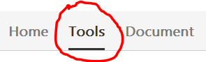

2. Now you can click on “Setup Assistant” on the right Tool Pane.

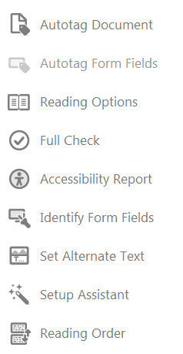

3. In the “Setup Assistant” dialog box, choose “Set options for screen readers” and click NEXT.

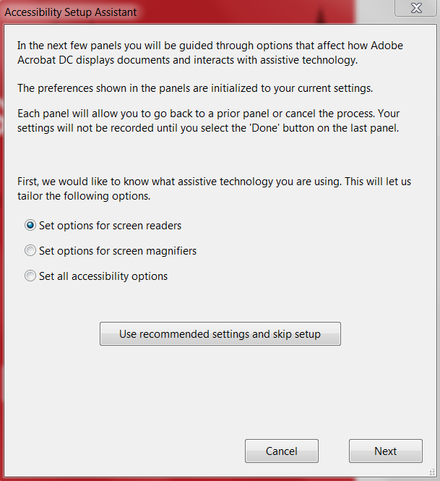

4. The next page will have selected by default “Infer reading order from document (recommended)”, leave that selected as well as any other default options selected on this page and click NEXT.

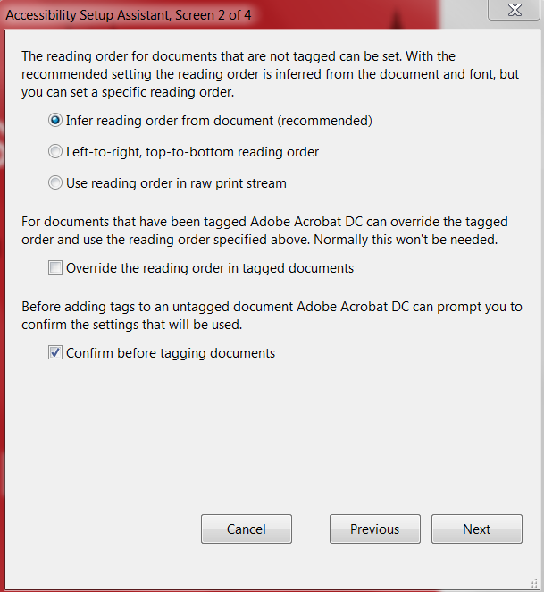

5. On this page do not change anything and click NEXT.

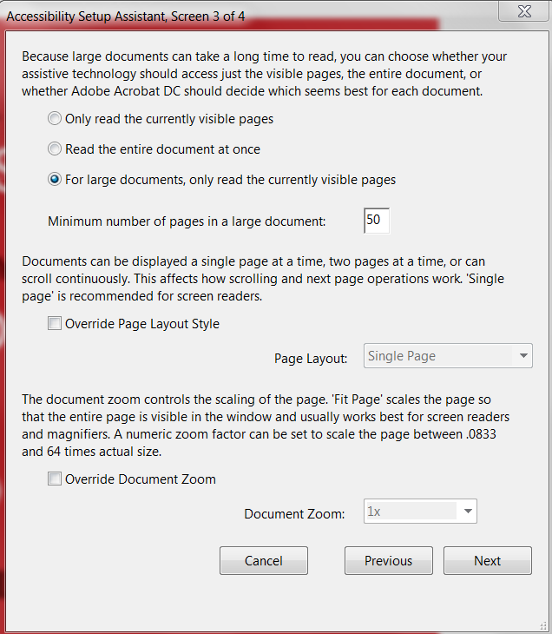

6. On the last page of the “Accessibility Setup Assistant”, do not change anything and click DONE.

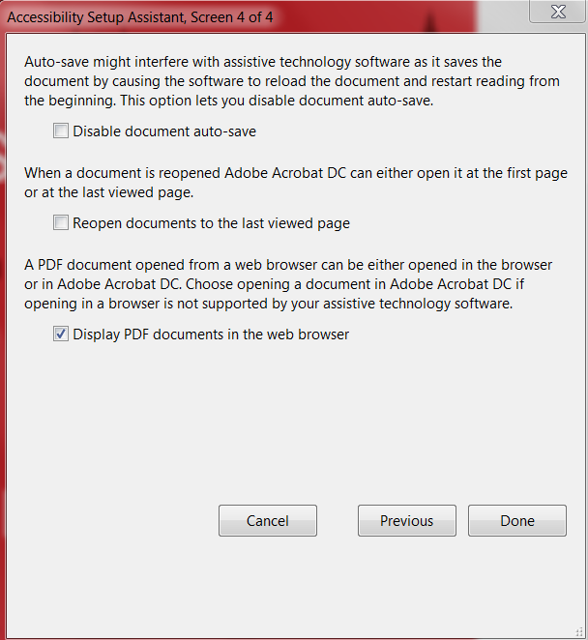

7. On the right Tools Pane close the “Accessibility” tool by clicking the “X” right above the Tools Pane.

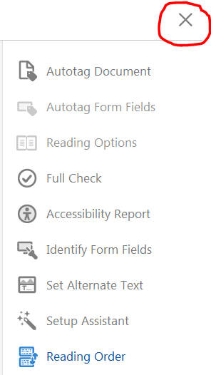

8. Back to the main Tools Pane, choose “Edit PDF” to perform text recognition (Optical Character Recognition) on the PDF to make sure any text in images is converted into editable text. This step must always be performed on any PDF. If the “Edit PDF” tool is not in the Tools Pane on the right, then you will have to add it in the list by clicking at the top, left of the application, the “Tools” menu. From this screen find the “Edit PDF” tool and choose “Add”, click “Document” to get back to the page screen, and then run the “Edit PDF” tool. When that is finished, click the “X” right above the Tools Pane.

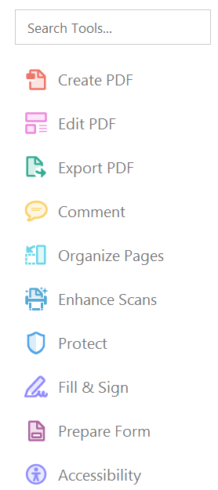

9. Next, choose “Accessibility” on the right Tools Pane. If this tool is not in the list, then you will have to add the “Accessibility” tool like the “Edit PDF” tool was added in the step above. Once this tool is added in the Tools Pane, click it. Choose the option to “Autotag Document”. This will add accessibility tags to the document in order for screen readers to access the PDF and read it to blind people.

10. Now, on the left side of the document is the Navigation Pane. In this list of options click on “Order”. If “Order” is not in the “Navigation Pane” you need to add it. To do this, at the top of the screen is the Menu Bar. Choose “View” from the Menu Bar, then Show/Hide, and then Navigation Panes. In this list, choose “Order” to add it to the Navigation Pane.

11. Click on “Order” in the Navigation Pane and you will see items on each page with boxes around them. These boxes have a number in them and they represent the Reading Order of how a screen reader will read the items on the page. Also, these boxes will show the word “Figure” and whether or not alternate text exists.

12. Not all figures will require you to add alternate text to them especially if they are for “eye candy” only. If a figure does not represent anything important in the PDF document and does not take anything away from understanding the content of the PDF, then you don’t have to add alternate text to it and select the check box “Decorative Figure”. However, if the figure is important to understanding the content of the PDF, then alternate text must be added to the figure and it is not a decorative figure.

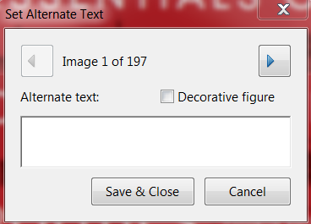

13. To add alternate text to critical figures, on the right Tools Pane click on “Accessibility” and then click on “Set Alternate Text”. This will open a dialog box and allow you to choose which figures to add alternate text or not. If you do not want to add alternate text to an image, then click the right arrow to move to the next figure. Once alternate text has been added to all critical figures, click Save and Close.

14. The PDF document is now tagged for accessibility with screen readers.

15. To verify the PDF for accessibility, you can run the Full Check tool which verifies whether the document conforms to accessibility standards, such as PDF/UA and WCAG 2.0. To use this tool, on the Tool Pane click on “Accessibility” to open the accessibility tools. On this window click the “”Full Check” tool.

16. After running the “Full Check” you can click on “Accessibility Report” to get a summary of the accessibility full check. Also, this report gives options to fix issues found from the “Full Check”.

IMPORTANT NOTE: If the PDF you are working with is a complex PDF document with all sorts of graphs, tables, images, etc., then advanced PDF accessibility remediation techniques will come into play. Even though you ran through the above steps that does not necessarily mean the PDF will be “properly” accessible because the “Autotag Document” feature tends to make mistakes and those mistakes require manual editing. The above steps may be good enough for simple PDF documents, but complex PDF documents will need further PDF accessibility remediation. This is why accessible PDF remediation can be labor intensive and take time to create a “properly” accessible PDF. In this case, advanced PDF remediation techniques come in to play. Advanced PDF techniques include using the “Reading Order” tool under the “Accessibility” tool on the right in the Tools Pane. The “Reading Order” tool allows you to change the type of tag an item on the page was set to when auto tagging the document. Also, this tool allows you to add table headers, add new tags to items in the PDF that were not tagged for some reason, etc. Besides using the “Reading Order” tool, other advanced tag editing features may be necessary such as renaming tags and moving items around in the tag tree so a screen reader will read items on the page in logical order, top-to-bottom, left-to-right, etc. These advanced accessible PDF remediation techniques will be addressed in another tutorial.

Revised: November 2015

